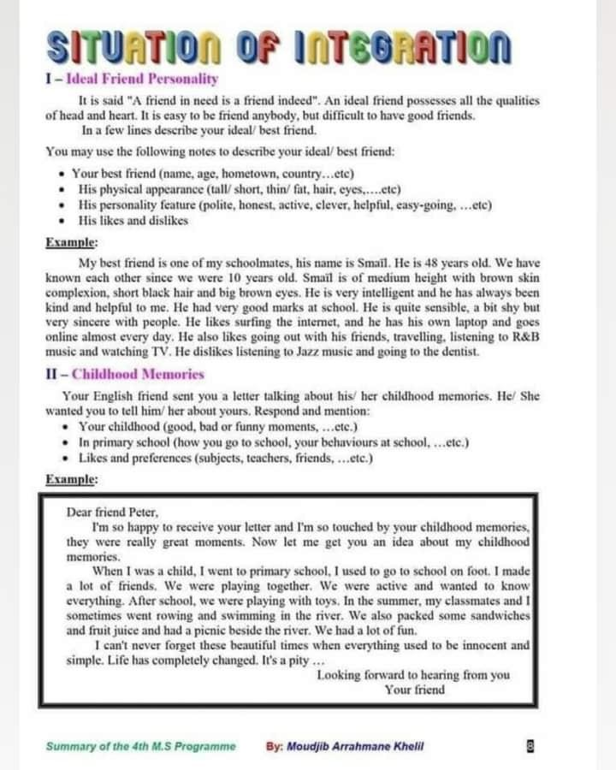

ID Csrd

6 a‹ ss aad .tAsAJ ss, F¥¥' £*?¥¥ Rs 6 mws ••d ••• Thb weB-ksaw• actb¥
dkd ee ... .So* ¥’. 7C..in.•- o¥‹ c 4 ¥¥rs ..

